Name: Malaika Roll No: 122

**Programming Activity**

**1.**Write a program to check if a number is positive, negative, or zero:

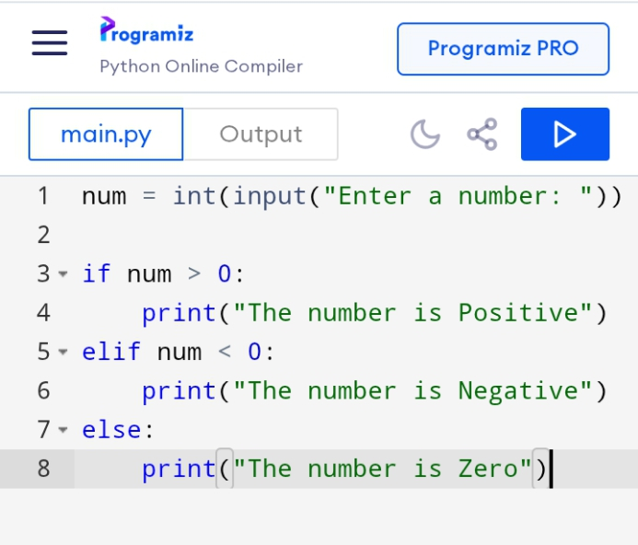

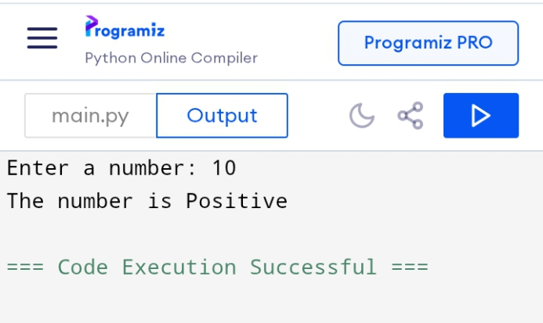

**2.**Create a program to determine weather a given year is a leap year:

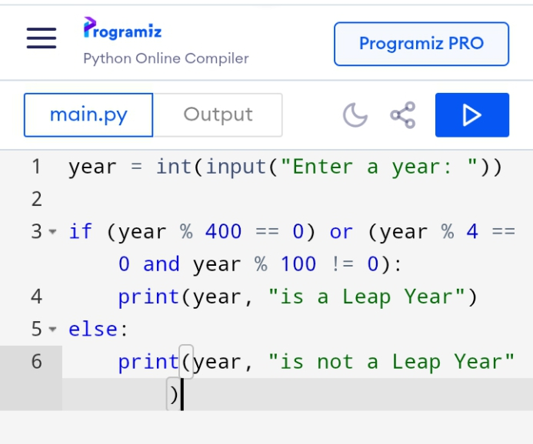

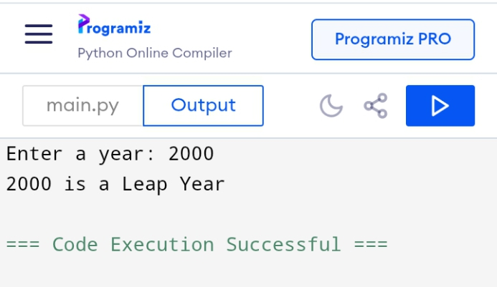

**3.**Buid a simple calculator that asks for two numbers and an operator (+, -, *, /) and prints the result:

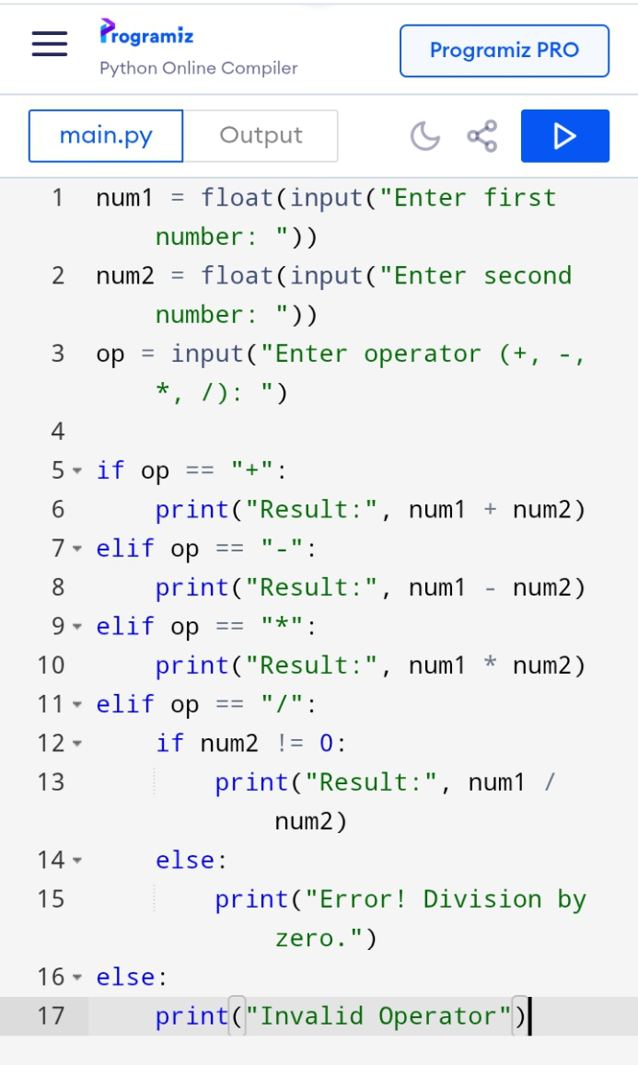

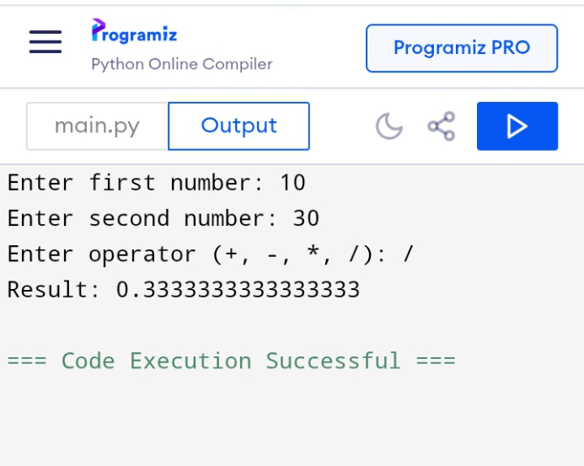

**4.** Write a python program that accepts a students marks and prints the appropriate grade based on the following criteria:

